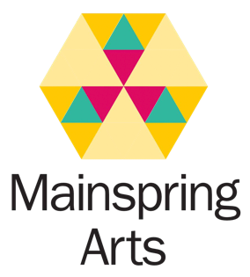

Square Peg Scripts
Application Form

Name:

Email address:

Address:

Phone number:

Please confirm that you are 18 or over and identify as neurodivergent: YES / NO (delete as appropriate)

How do you feel your neurodivergence has affected your ability to access creative opportunities? If you’re comfortable doing so, please share more details of your neurodivergence. Your answer won’t in any way impact your application.

Please confirm that you are available to travel to London on the following dates:

Fri 16-Sun 18 Nov 2018: First workshop weekend
Fri 31 Nov-Sun 2 Dec 2018: Second workshop weekend
Fri 14-Sun 16 Dec 2018: Third workshop weekend

YES / NO (delete as appropriate)

The workshops will run from 10:30am to 3:30pm on Saturdays and Sundays, and will take place at Riverside Studios in Hammersmith, London. Mainspring Arts will reimburse your travel costs and provide accommodation for the Friday and Saturday nights. If you need a personal assistant to accompany you, we will also fund their travel and accommodation costs.

Please tell us about any writing experience you have. This can be anything at all, from comic books you wrote as a child to stories published in a magazine. Use another sheet of paper if you need to (same for all the other questions!)

What do you enjoy about writing?

Why do you want to take part in Square Peg Scripts?

Would you like to be added to the Mainspring Arts mailing list? We’ll only email occasionally to share news of our exciting opportunities and projects. YES / NO (delete as appropriate)

Please also submit:

- A piece of writing for performance that is between five and ten minutes in length. This can be a complete short play or an extract from a longer piece of work, a film script or any piece of writing designed to be performed. It can be on any subject at all. Please save the file as [FIRSTNAME LASTNAME] SQUARE PEG SCRIPTS. Please don’t put your name anywhere on your writing submission, other than in the filename. All submissions will be anonymised prior to reading.
- A completed equal opportunities form (please download the form from the Square Peg Scripts page on our website).

If you need to send us a hard copy of your application and submission, please email us at hello@mainspringarts.org.uk

The deadline for applications is midnight on 10 October 2018.

Thank you – we can’t wait to read your submission! The Mainspring Arts team

